**Conceptual Design**

The conceptual design of a database for a Health and Fitness Club Management System encompasses the high-level structure and relationships among various entities without delving into the technical aspects or database schema specifics. It focuses on defining entities, their attributes, and the relationships between them.

**Entities:**

1. **Member:** Represents individuals registered with the club, containing attributes like name, contact information, membership type, fitness goals, and health metrics.
2. **Trainer:** Contains information about the fitness trainers associated with the club, including their name, contact details, specialization, and certification.
3. **Admin Staff:** Represents administrative personnel managing club resources, featuring attributes such as name, contact information, and position within the organization.
4. **Personal Training Session:** Captures details of one-on-one training sessions, including the trainer, member involved, date, time, and session notes.
5. **Group Fitness Class:** Records details of classes offered, such as class name, date, time, and the associated trainer.
6. **Event:** Contains information about club events, including event name, date, and time.
7. **Room:** Represents available spaces within the club premises that can be booked for classes or events.
8. **Equipment:** Contains details of fitness equipment available at the club, including equipment name and maintenance status.
9. **Billing:** Tracks financial transactions related to membership fees, personal training sessions, and other services rendered to members.
10. **Loyalty Program:** Manages the loyalty points earned and redeemed by members for club services.

**Relationships:**

* Members can participate in multiple Personal Training Sessions, Group Fitness Classes, and Events.
* Trainers conduct multiple Personal Training Sessions and lead various Group Fitness Classes.
* Admin Staff oversee and manage Rooms, Equipment, and Billing.
* Rooms can be booked for Group Fitness Classes and Events.
* Equipment is utilized during Personal Training Sessions and Group Fitness Classes.
* Billing is associated with specific Members for services received.
* Loyalty Program maintains records of Member points earned and redeemed for future services.

**ER Diagram**

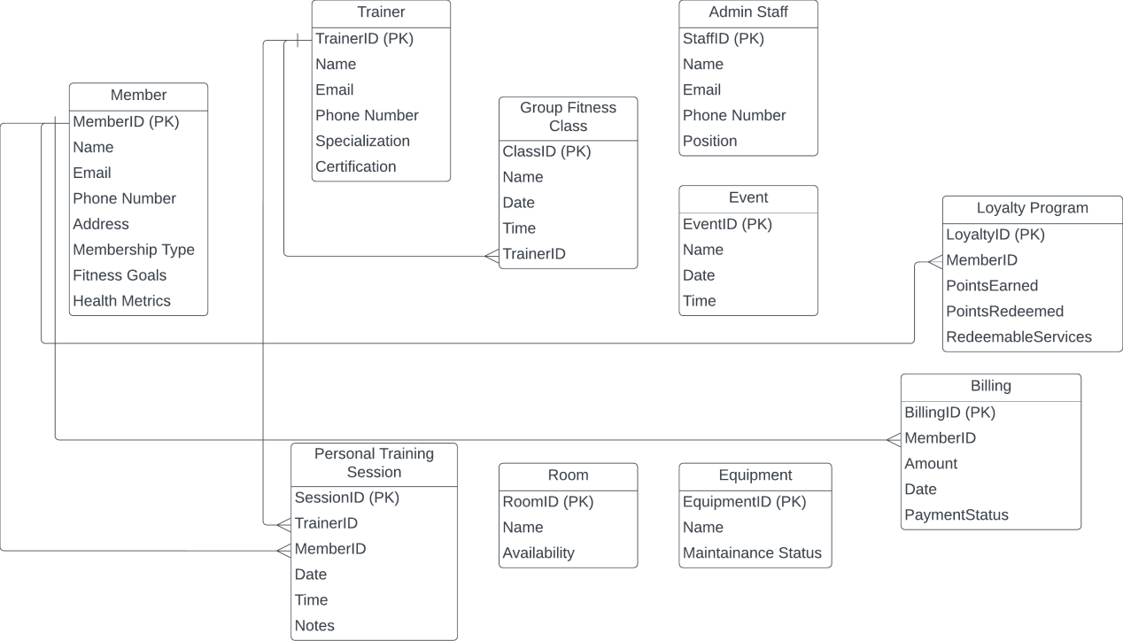

**Normalization of Relational Schemas**

The functional dependencies for the Health and Fitness Club Management System are:

* **MemberID -> Name, Email, Phone Number, Address, Membership Type, Fitness Goals, Health Metrics**
* **TrainerID -> Name, Email, Phone Number, Specialization, Certification**
* **SessionID -> TrainerID, MemberID, Date, Time, Notes**
* **ClassID -> ClassName, Date, Time, TrainerID**
* **EventID -> EventName, Date, Time**
* **RoomID -> RoomName, Availability**
* **EquipmentID -> EquipmentName, MaintenanceStatus**
* **BillingID -> MemberID, Amount, Date, PaymentStatus**
* **LoyaltyID -> MemberID, PointsEarned, PointsRedeemed, RedeemableServices**

The relations appear to satisfy at least the third normal form (3NF) by handling transitive dependencies and establishing proper primary keys.

Further decomposition might be necessary to ensure adherence to higher normal forms such as 4NF or 5NF, especially if there are complex relationships or multivalued dependencies not evident from the given information.